Maths – Using money and adding coins together.
In the absence of being able to go out to use money here is a fun way to use coins and still learn to add them up.
Take some card and a range of coins. This can be done with just pennies or a wide range of coins. No notes or cards at this stage!!
Depending on your child’s abilities start with just using pennies and move on to a broader range of coins once they are confident in recognising and using pennies. Some children will need more help than others but that’s what learning is all about.
On your card or paper drawn simple stick shape quite large – a dog, a house, a car etc.
Then use the coins to either fill in the shape or lay them on the lines of the drawn shape.
When you are happy that the shape or picture is full or outlined add up all the coins to find out how much the picture is ‘worth’.
See who can make the most ‘expensive’ picture.
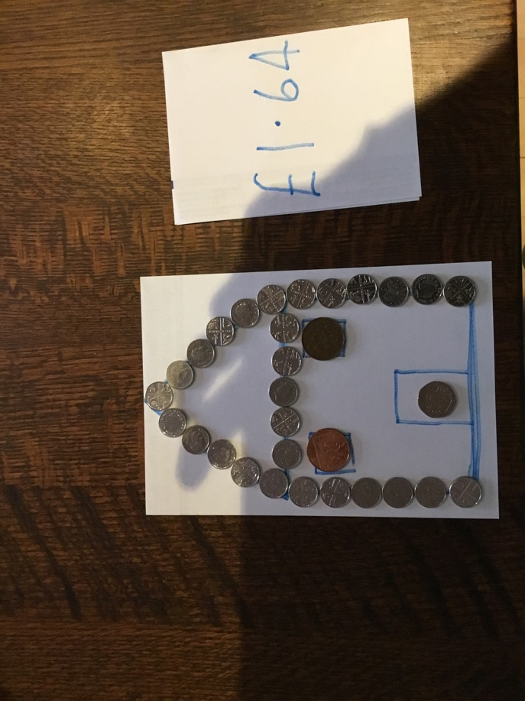
I have had a good and found my house to be worth £1.64.
