At home practical science experiments
- Ice exploration
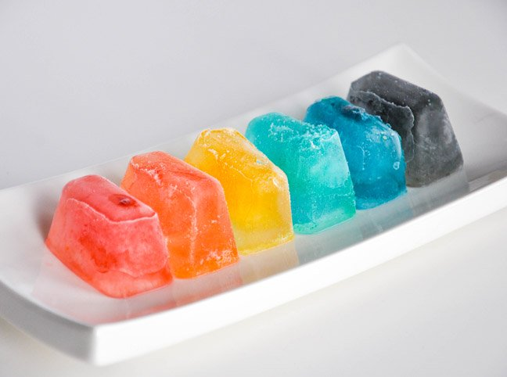
Adding food colouring and flavouring to ice cubes is a great way to create a sensory experience that teaches temperature as well as freezing and melting. Students can explore the ice cubes with their hands and mouths as well as experience the melting sensation of the ice cube and how it turns to water. A way to focus on the melting part of this learning idea is to leave the ice cubes clear but put in some small fruit that your child likes (berries work well!) and then encourage your child to melt the ice cubes by holding them in their hands to get to the fruit.
Extension: make the ice cubes only primary colours and put two different colours into a cup. Ask what colour do you think it will make when both ice cubes mix and melt together. Wait for ice cubes to melt to test predictions.
Key words: cold, frozen, hot, melt

- Magic milk

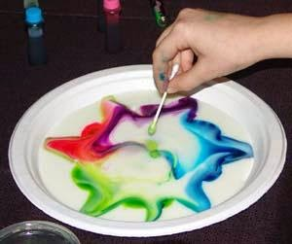

For this you will need a flat tray, like a baking tray, full fat milk, food colouring, washing up liquid and cotton buds. Pour the milk into the tray (or encourage student to depending on dexterity; can help work on dexterity if that something you’re interested in working on) add about eight drops of different coloured food colouring onto the milk, it works best with at least three different colours. After that dip the cotton buds into dish soap and then place onto the drops of food colouring. The colours should scatter. If you haven’t got cotton buds it works just as well to squeeze a small drop of dish soap directly onto the food colouring.
How it works (for parents): this experiment works because washing up liquid is designed to go after the fat on your pots and pans and break it down so it can be washed off. When you drop it onto the tray it goes for the fat in the milk and breaks it down, causing the food colouring to spread.
Key words: Colour (colour names), spread, milk

- Walking rainbow

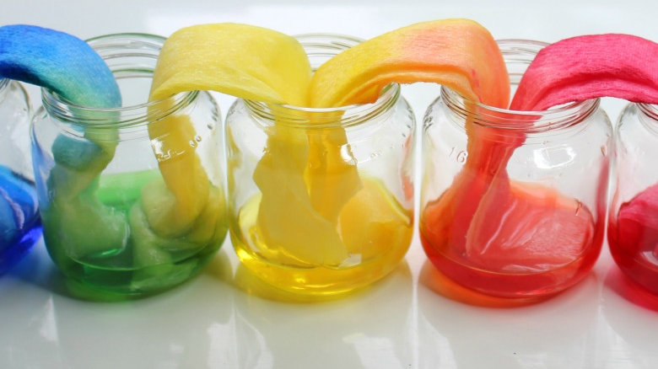
For this you will need six clear plastic cups/ glasses, water, red, yellow and blue food colouring and paper towels/ kitchen roll.
To start with fill three of the six plastic cups about ¾ of the way full with water. To promote independence and dexterity encourage your child to do this with a jug. Put yellow food colouring in one of the cups of water, blue food colouring in one and red colouring in one. Arrange the cups in a circle (you could draw a circle onto a piece of paper or ask your child to do this to reinforce the shape and make it easier to arrange the cups). Arrange the cups so that there is a full one next to an empty one all the way round. Next fold 5 sheets of kitchen roll into three so that you have five long strips and put them in the cups from one to another. Whilst the coloured water moves its way up the kitchen roll, and if your child is able, ask what colours you think are going to be made when the coloured water mixes. Eventually the colours should spread all the way along the kitchen roll and into the empty cups where they mix and create a rainbow.
Extension: Another way to observe the different colours before you put the kitchen roll in the cup is to grab a torch and shine it through the cup with the dyed water in. Ask your child to stand on the other side of the cup to observe the light shining through.
Key words: Colour language, spread, circle

- Skittle colour wheel

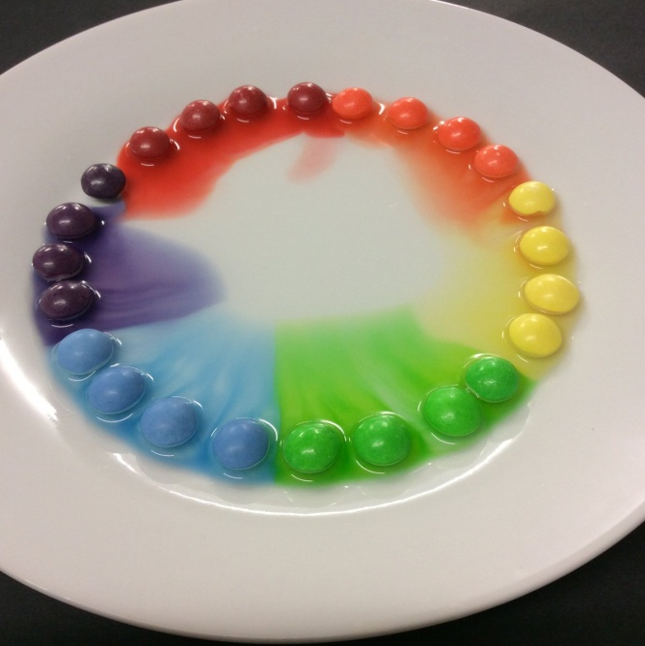
This experiment is a yummy way for students to learn about the colour wheel. All you need is a bag of skittles/M&M’s both work so it can depend on your child’s preference. To extent the activity I would start by asking your student or reinforcing the colours of the sweet. Either ask what colour the sweet is and if they guess correct they are allowed to eat it, or show the sweet to your child tell them the colour and then as they eat it reinforce the colour using a second sweet. Once all the colours have been identified either ask your child to arrange the sweet around the edge of the plate or arrange them encouraging your child to watch as you do so, reinforcing the colours as you put them down. If your child is doing it and are struggling to recognise colours it might help to give them a choice of two and ask ‘which one is the red one’, and after the right colour has been recognised. All you need to do now is slowly pour water onto the plate to the point where it covers two thirds of the sweet and watch your colour wheel develop.
Key words: Colour language

- Shaving cream clouds
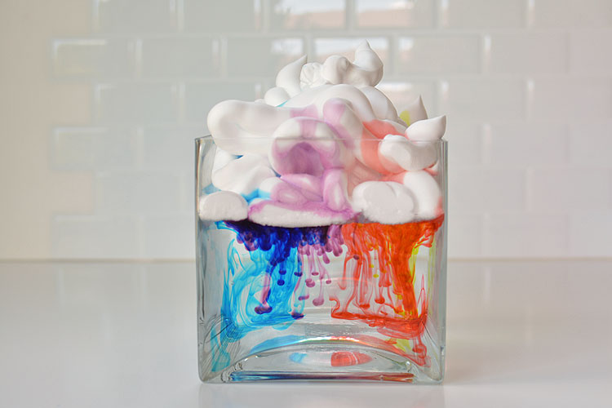
For this experiment you will need a glass container that is see-through. It can be a cup or a vase depending on how big you want your cloud to be. Shaving foam, water, small containers, An eye dropper or syringe (a teaspoon also works fine) and food colouring.
The first job to do is to mix the foot colouring with water. For this the less water you use (so the more concentrated the food colouring) the faster the rain will drop but, on the other hand, the more water the you mix the food colouring with the more rain you can make.
Mix the food colouring with some water in the small containers. Fill the larger glass container (vase or cup) with water until it is about 2/3rds full. Gently spray shaving foam onto the top of the water. Use your eye dropper syringe or teaspoon to put drops of the different food colouring solution onto the shaving foam cloud. The closer your drops are too the edges the faster it will rain. As way of explanation if it’s appropriate for your child, the water in the vase is air, the shaving foam is clouds and the food colouring is rain. The fuller the cloud is with water the more likely it is to rain. Otherwise just admire the beautiful colours that drop down from the shaving foam.
Extension: Shaving foam is a great sensory experience for students without it being for an experiment. If you’re worried about your child putting it in their mouth, foam soap is a great alternative. It can be really enjoyable for your child to feel and smear over a table. It can also be associated with weather learning by putting some on your hands and clapping to look like snow.
Key words: cloud, rain, water
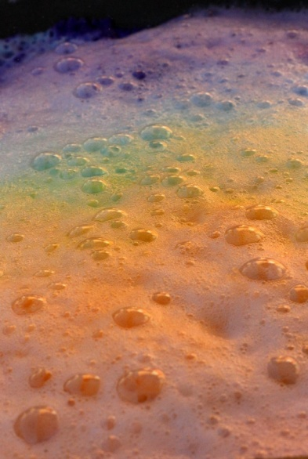
- Fizzy rainbow

This is a great one for students who enjoy sounds and smells for sensory exploration. You will need a baking tray, a bowl, a small container, baking soda, food colouring, vinegar and teaspoons.
First of all mix your food colouring with a bit of water in the small container. Put four spoonfuls of baking soda into the bowl and add the food colouring solution. The baking soda should start to clump together but not be wet. Pour the colour baking soda onto the baking tray in a line. Repeat this for as many colours of food colouring as you have until you have lines of coloured baking soda on the baking tray. This is a great point for your child to admire the colours and feel the baking soda as it should squish together when you prod it. To create a more smelly sensory experience, use your teaspoon to put drops of vinegar onto the baking soda. The baking soda should fizz up which is a great sound to hear and it should also produce bubbles which can be fun for your child to pop as you add the vinegar.
Key words: fizz, pop, rainbow, smell

- DIY Lava lamps
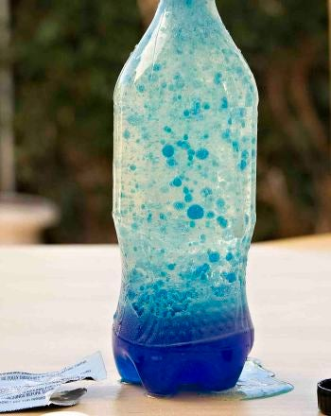
For this experiment you will need a see-through bottle, oil, water, food colouring and Alka Seltzer.
Fill your bottle just over half with oil and then add water so that the bottle is almost full. Add about 10 drops of whatever coloured food colouring to the bottle then break the Alka Seltzer into four pieces. Drop each piece in one at a time and wait until one piece stops bubbling before you add the next. As well as encouraging your child to look at what is happening also encourage them to listen to the sound of the Alka Seltzer fizzing in the bottle. Encourage students that are able to predict what will happen when the fizzy Alka Seltzer empties the bottle. Can they communicate what they see in the bottle during the experiment? Use sound words to describe what they hear when the bottle lid is off.
Extension: To make this a more sensory experience for students add glitter and something that has a smell like vanilla extract or lemon juice. This will mean that your child can access smell as well as sight and sound, and also the glitter adds an extra thing for students to look at when the Alka Saltzer is added.
Key words: Oil, fizz, colour words, bubbles

- Tinted flowers

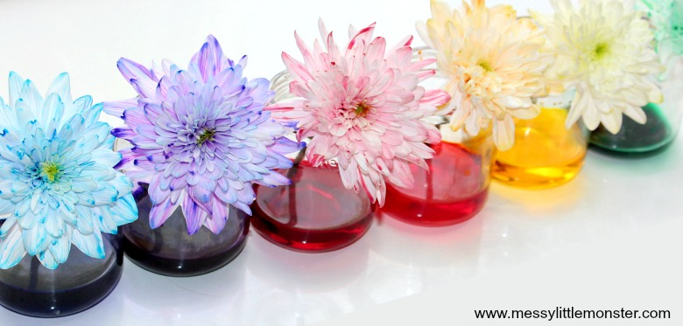
You will need white flowers, small vases or see through cups, water and food colouring.
This experiment is another good one to explore recognising colours. If you want to work on your child’s dexterity there are also options for that when pouring water into the vases and squeezing to add food colouring to the water. Encourage your child to use both hands to do this to work on strengthening both hands.
Fill the vase/ see through cup with water and add a few drops of food colouring. Cut off the end of the flower and put it in the water (the shorter the stem the quicker it will take for the flower to change colour).
As the student or you adds the food colouring to the water in the vase, ask them to identify the colour where able or identify it for them. Before the flower goes in ask your child that if the plant drinks all this coloured water through its stem what colour do you think it’s going to turn in its petals.
Extension: if your child is able, ask them to think about what else a plant needs to grow apart from water. Encourage your child to find it in the garden and feel it to gain a better understanding and have a sensory experience to reinforce learning.
Key words: flower, stem, water

- Edible chocolate play dough.
This experiment can be adapted to suit the interests and needs of every student, making it about measuring and actually making the play dough for those who are able to and, for those who enjoy a more sensory experience, making it for them to feel, taste and play with.
For this you will need a can of condensed milk, a bar of chocolate, corn starch and cocoa powder for colour.
First, place the condensed milk into a saucepan along with the chocolate and 1/3 of a cup of cornstarch. Next, cook over a medium heat until the mixture is fully incorporated. Then you can add the additional cocoa powder for the desired colour. The mixture should start to stick together to form a ball. Add more cornstarch as needed to reduce the stickiness but make sure not to add more than 2/3 of a cup or it will lose its stretchiness. Let the mixture cool until its comfortable to touch and then need it until the texture is uniform.
The play dough will eventually harden after cooling but it can be reheated in the microwave and then re-kneaded to turn it back into play dough.
Key words: stretchy, sticky, dough, chocolate

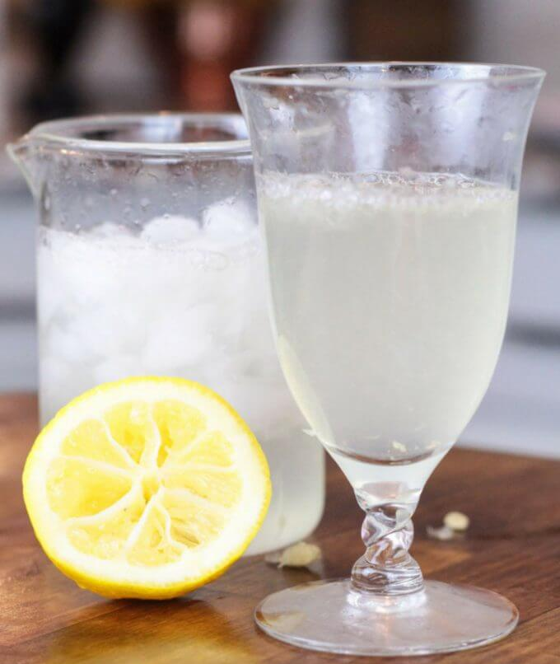
- Five senses lemonade

Again, like the previous experiment, this activity can be adapted to suit the interests and needs of every student. For those who are able this experiment can teach about food preparation- boiling water in a kettle, juicing lemons, but for those who learn better through sensory experiences this experiment has the opportunity to use all five senses and so can also be a brilliant opportunity for learning.
For this experiment you will need sugar, water, lemon and baking soda.
First boil two cups of water in the kettle or on a stove. If you have boiled the water in the kettle pour it into a pan and put it on a medium heat. Next add two tablespoons of sugar for each glass of lemonade you want to make. Dissolve the sugar in the boiling water, stirring all the time. Once the sugar is dissolved let the sugar syrup cool.
Juice the lemons and add them to your glasses (about one lemon for each glass). Add the sugar syrup to the glasses and then add about a quarter of a teaspoon of baking powder to each glass and listen to/ watch it fizz.
It’s a great experiment to sample at every stage. Does the sugar syrup smell like it tastes? Does it taste sweet or sour? What does the lemon taste like? Does it taste different if you eat it too its juice? Is the lemonade nice without the fizz? Does it taste different when you add the bicarbonate of soda? Can you see the bubbles in the glass when it fizzes? What sound does it make when you add bicarbonate of soda?
Extension: if your child is enjoying this you could add some ice to the glass. Feel that the ice is cold before you add it. Retry the experiment- the warmer glass should fizz straight away and the cold glass should take longer to fizz.
Key words: Lemon, sweet, sour, sugar, fizz

- Taste testing without smell
This experiment is great to explore taste and texture, as well as senses through a delicious experiment.
You will need a small piece of apple, a small piece of potato, a grape, a blueberry, raspberry, lemon and lime. Essentially any foods that have similar textures. Ask your child to close their eyes and, if able to block their nose. With their eyes closed can they tell the difference between the apple and the potato when they taste it? What about if they hold their nose? Ask your child to describe the taste then choose which food they have just eaten out of the two. Through this you can explore taste and texture of food as well as, if your child is able to understand, that smell can help with taste.
Extension: If you want to this experiment can be just about recognising food. Have pictures of food in front of you then articulate to your child what each food is. Pass it to them to explore with their senses then ask, out of two pictures, to indicate which one they have just eaten.
Key words: food names, taste, smell

Invisible ink
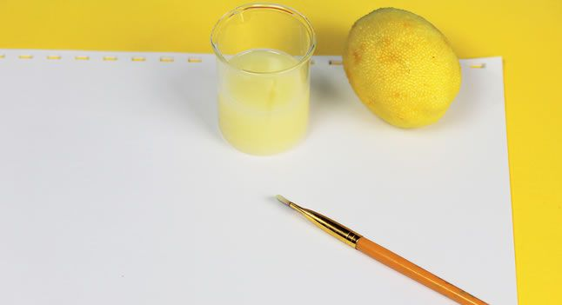
This experiment is really good for helping students to work on their writing or mark making, using a bit of science.
For this experiment you will need a lemon, water, a spoon, a bowl, a cotton bud or paintbrush, white paper and a lamp or light bulb.
Squeeze some lemon juice into the bowl and add a few drops of water. Mix the water and lemon juice with the spoon. Dip the cotton bud into the mixture and write a message onto the white paper. Either you can do the writing or your child can do it depending on if it’s about mark making and letter formation, or recognising letters. Wait for the juice to dry so it becomes completely invisible. When you are ready to read your secret message or show it to someone else, heat the paper by holding it close to a light bulb.
The science explained: Lemon juice is an organic substance that oxidizes and turns brown when heated. Diluting the lemon juice in water makes it very hard to notice when you apply it the paper, no one will be aware of its presence until it is heated and the secret message is revealed.
Key words: Invisible, letter names, lemon juice

- Dish soap putty
For this putty you only need two ingredients so it’s great if you just want something quick and sensory for your child to explore. All students will enjoy it because it’s slimy and gross. You only need washing up liquid and cornstarch. You can add food colouring and glitter if desired to make it more interesting to look at.
Mix 1 and a half tablespoons of washing up liquid with 2 tablespoons of cornstarch and stir together best you can for about 10 seconds. Once it becomes difficult to stir get your hands in there and start needing. This is where you can add colouring and glitter if you want to. Work the putty with your hands until all the ingredients in the bowl are combined. Some washing up liquids can vary so if the putty is a bit dry just add a little more.
Key words: Sticky, stretchy, slimy,

Re-grow your own veggies.
Below I’ve put some examples of the conditions that certain veggies need to re-grow. This is great to help encourage students to take an active role in food preparation, be responsible for something over an extended period of time, to learn what plants need to grow, and also for sensory exploration through smells, taste and touch when the veggies are re-grown.
Potatoes
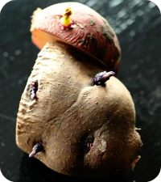
Pick a potato that has a lot of good formed eyes, and cut it into 2-3 inch pieces, taking care to be sure that each piece has at least 1-2 eyes on it. Leave the cut pieces to sit at room temperature for a day or two, which allows the cut areas to dry. Potato plants thrive on a high-nutrient environment, so it is best to flip compost into your soil before you plant. Plant your potato pieces about 8 inches deep with the eye facing up. Cover it with 4 inches of soil, leaving the other 4 inches empty. As your plant begins to grow and more roots appear, add more soil.

Lettuce and Cabbage
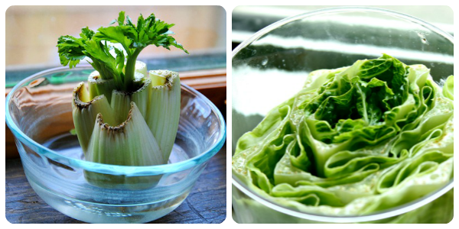
These all are re-grown by placing the roots in a dish of water. Cut the leaves or stalks off to about an inch above the roots. Place the root end in a dish of water. Make sure that the roots are inside of the water, but do not submerge the rest of the plant. Place in a sunny window & spray with water 1-2 times a week to keep the top of the plant moist.
Onions
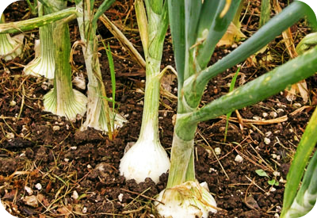
Onions are one of the easiest vegetables to re-grow from scraps. Just cut off the root end of your onion, leaving a 1’2 inch of onion on the roots. Place it in a sunny location in your garden and cover the top with soil. Make sure to keep the soil moist by watering when needed. As you use your home-grown onions keep replanting the root ends you cut off.

Garlic
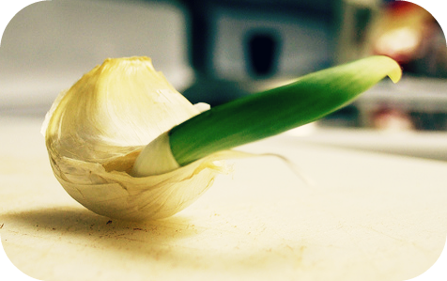
You can re-grow a plant from a single clove. Simply plant it with the root-end down. Sit the plant in a sunny window. Once established, cut back the shoots and the plant will put all its forces into producing a nice garlic bulb .You can repeat this process with a clove from the new bulb you have just grown.
Key words: plants, vegetables, soil, sunlight, water

- Ice-cream in a bag
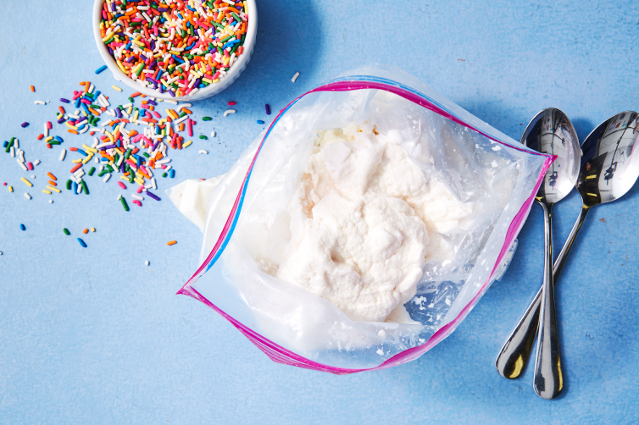
This final experiment is really fun, can get kids active and makes delicious ice-cream at the end.
You will need half a cup of milk and half a cup of cream, 1 tablespoon of sugar, 1 and a half teaspoons of vanilla extract, ice, 1 quarter of a cup of salt and two zip lock bags; one big, one small. To make the ice-cream put all the ingredients apart from the ice and the salt into the small zip lock bag and close it properly (double check its closed so that you don’t get salty ice-cream). Put a cup of ice and a small handful of salt into the big zip lock back then put your small bag into the big one. Keep adding ice then salt around the small bag until the big bag is almost full then zip closed. Put on some gloves then shake the bag and jump around encouraging your child to get active for about 8 minutes. Make sure that the zips on both bags stay closed. Open the big zip lock bag and take out the small one. Wipe around the opening of the small one to ensure there is no salt on top that will sneak in. Inside the small bag you should have ice-cream. If you want to add any other flavouring e.g. lemon, just add it at the beginning.
The science explained: When you add salt to the ice it forces the ice to melt. Before the ice can melt it needs to borrow heat from somewhere, which it does from the other ingredients in this experiment, making them get colder.
Key words: ice, ice-cream, cold, salt, shake

