CURRENT AFFAIRS
SUMMER 1
Here are the themes I was due to teach in school. I have adapted them slightly and given you a few ideas of things you might like to do at home.
Have fun!

Week One
Theme - Anniversary of the sinking of the Titanic
- Research the Titanic – look at pictures of the boat, watch footage on YouTube, discuss how it sank and why.
Activity
- Floating and sinking activity – what materials make the best boat?
- Depending on your child’s ability you can either
- Construct toy boats from different materials – lollypop sticks, cardboard boxes, corks, cleaning sponge etc. Some visual ideas on here
https://www.science-sparks.com/materials-make-best-boat/
- Or simply place different materials in water and see which ones float and which ones sink.
Nice activity to explore in a garden or outside space – involve other siblings – they could also make boats etc.
Week two
Theme – Earth Day
- Discuss the simple things we can do to protect our Earth – talk about recycling and how we can do it at home. Show your son/daughter the different bins you have at your house and what they are used for.
Activity
- Show your son/daughter a picture of the things you can recycle in your household bins– similar to this one
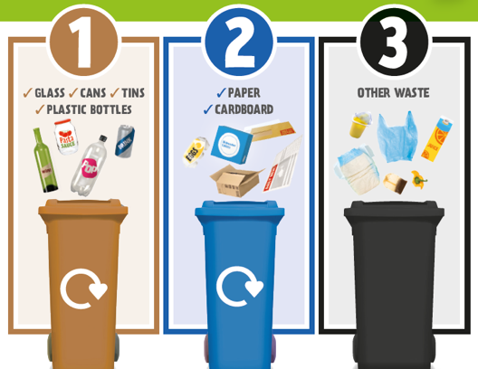

Put your son/daughter in charge of recycling in the home. Using the council poster above – give them items – for e.g. a plastic bottle and see if they can locate which bin it needs to go in.
Depending on their ability can they recreate the poster above to remind other members of their family what they should try and recycle around the home.
Also remember to remind them that it is important to wash their hands after handling rubbish and bins, especially at the moment. There are some good clips on YouTube to show them how to do this properly.
https://www.youtube.com/watch?v=S9VjeIWLnEg

Week Three
Theme – Children’s book Week
- In school we were going to do a sensory story on based on Dr. Foster and different weathers. I do not have an electronic version of this to send unfortunately – but the themes of it were to explore different weathers – ice (ice cubes) snow storm (blow flour), snow (fake snow) thunderstorm (listen to sound effects watch footage), rain (create water sprays, use musical instruments to make the sounds etc.) wind (create a wind storm using fans).
- In this instance it may be easier to share your son/daughters favourite story with them.
Activity
- Share your son/daughters favourite story – create the characters from the story – in model form or draw them, colouring sheets etc.
- Dress up as characters from their favourite story – watch footage of the story if available on the internet.
Week Four
Theme – VE day
- Explain what VE day is – show footage from the internet https://www.youtube.com/watch?v=fwxL0pk2A6s
- Explain there was a party and lots of people celebrated because it was the end of the war.
Activity
- Make some world war 2 scones that would have been eaten at the VE day parties
Potato Scones
6 oz flour
4 oz mashed potato
1 teaspoonful baking powder
½ teaspoonful salt
1 oz butter
4-5 tablespoonfuls milk
Mix the flour and salt. Add the baking powder and work into the mashed potato. Rub in the butter. Blend to a soft dough with milk. Roll out to ¼ inch thickness. Cut into rounds. Brush the tops with milk. Bake on greased baking sheets for 15 minutes in a hot oven. For a sweet scone add 1 oz sugar.
-Recreate a VE day party – decorate a table with union Jack flags etc. and try the scones you have made with a cup of tea (get your son/daughter to work on their independence skills and have a go at making the tea themselves).
Week 5
Theme – World Fairtrade Day
- Look at different Fairtrade products if you have any around the home.
- Show students the label. Can they find the label on any products you may have at home?

Activity
- Chocolate is one of the most popular fair trade products. If possible, try and get some fair trade chocolate to use on the following recipe but if not ordinary chocolate is fine to use.
Preparation time15 – 20 minutes What you’ll need
- 60g/ 2 oz unsalted butter
- 3 table spoons golden syrup
- 1 x 100g bar milk or dark chocolate
- 90g/ 3 oz Rice Krispies
How to make them
- Melt the chocolate in small bursts in the microwave or in a bowl over a saucepan of simmering water
- Add the butter, cut in to small pieces, stir in till melted
- Add the syrup, stir
- Add the Rice Krispies and stir in to the chocolate mix, gently
- Spoon in to 12 bun cases
- Leave to cool
- If possible make one batch of buns with fair trade chocolate and one with normal chocolate – can you tell the difference – which do you prefer?

Week 6
Theme – FA Cup Final Week (Obviously this has been cancelled but you can still explore the theme)
- Do you support a football team? Look at the football teams we have in Sheffield – we are lucky to have two? Do you support a Sheffield team or another team?
Activity
- Get outside and play football!
- Use whatever you can to make goal posts and see how many goals u can past mum/dad/carer/siblings!
- If you need ideas for passing/skill games etc. use the schools Twinkl log in details and search KS1 football skills pack
- Make a poster of your favourite football team.

