**Music at home!**

**Keep happy, keep healthy.**

**Keep playing, keep singing!**

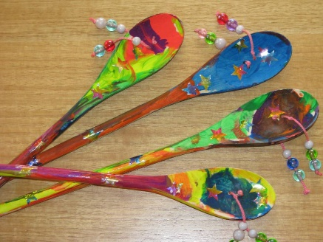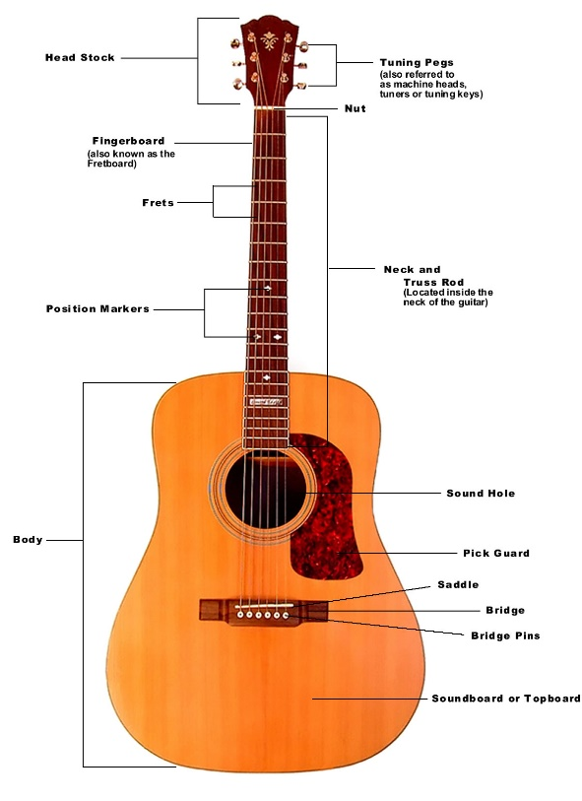**Build a musical instrument – adapt these ideas with anything you have in your cupboard at home for some creative instruments!**

Guitar!

Dede Drum!

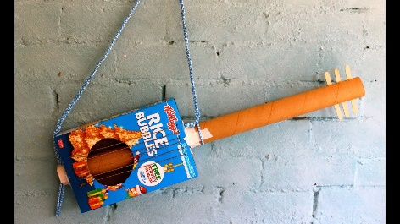

**Ideas:**

* **The body – tissue box/cereal box/Tupperware/ large plastic bottle**
* **The neck – wrapping paper tube/kitchen roll tube, thin piece of wood or cardboard**
* **The strings – elastic bands/string/**

**wool/thread**

* **Tuning pegs – rolled up card or paper**
* **The bridge - a crayon/pen/pencil**
* **Frets – pieces of paper/draw them on with felt tip or colours**
* **Strap – string/wool/layers of thread/belt**

**Other bits you might need:**

* **Sellotape**
* **Glue**
* **Colours, paints, crafts to decorate**

**Ideas:**

* **Body - kitchen utensils e.g. wooden spoon/metal spoon/small frying pan**
* **Attach string /wool or sewing thread**
* **Beater - bead /small stone/button**
* **Spin stem with your hands to create the sound!**

**Other bits you might need:**

* **Paint/colours/food colouring for decoration**
* **Glue or Sellotape**

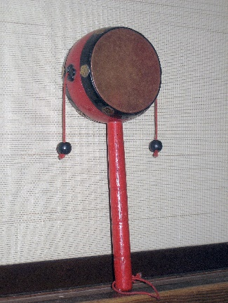

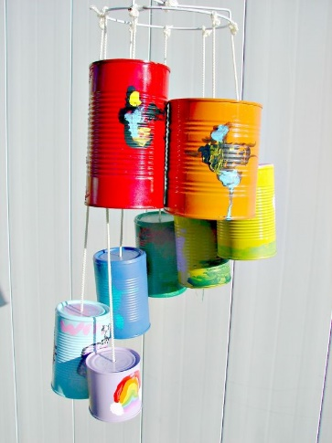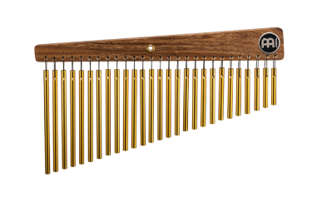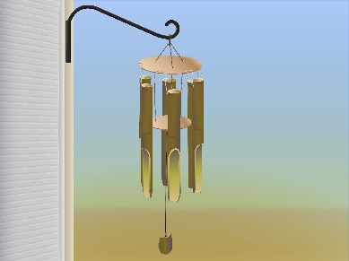

**Ideas:**

* **Chimes – tins of varying size (e.g. beans, sweetcorn and tuna)/old cutlery/keys**
* **Something to hang them from – piece of wood/metal frame/washing line/reshaped coat hanger**
* **Attachment – string/wool/sewing thread/cords from clothes (hoody or waistband tie)**

**Tips:**

* **Turn can upside-down and make a hole in the bottom, thread through the string and tie a large knot on the inside so it doesn’t fall off!**
* **If using cutlery or keys just tie them on whichever works for you!**

**Other bits you might need:**

* **Drill or screwdriver for making holes (please be careful if using any equipment like this and ask a parent to help and observe!**
* **Paint/colours/food colouring for decoration**
* **Glue or Sellotape**

Wind chimes!

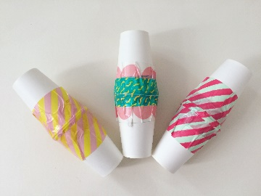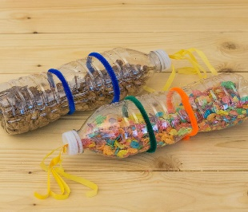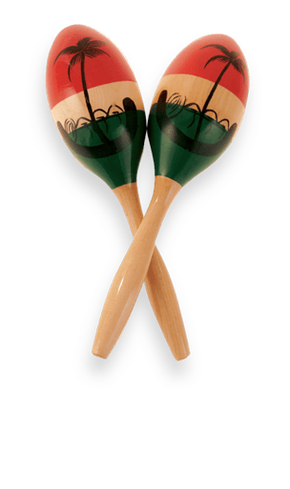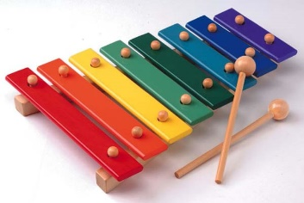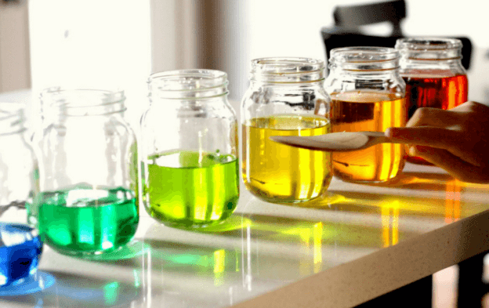

**Ideas:**

* **Case –decorated plastic bottle/paper cups/plastic cups/Tupperware box**
* **Interior – dried pasta/rice (coloured if you wish)/small pebbles/cereal/beads/buttons/liquids**
* **End decorations – ribbons/pipe cleaners/papers**

**Tips:**

* **Ensure you tape the cap of any bottle on to make sure it is safe and secure**
* **Tape 2 cups together or cover the top of one cup with a balloon material or paper for different sounds**

**Other bits you might need:**

* **Paint/colours/food colouring for decoration**
* **Glue**
* **Sellotape**

Percussion shaker!

**Ideas:**

* **8 Jars – ensure all jars are the same or very similar size. You could also use bottles (best effect is with glass rather than plastic)**
* **Water – colour the water using food colouring to create a good effect and to clearly see the water level**
* **Beater – you can use any piece of cutlery or wood for this**

**Tips:**

* **The higher the water level, the higher the pitch of the sound. The lower the level, the lower the pitch**
* **Experiment with making a tune. A scale (from lowest to highest) should get gradually higher, what happens when you skip notes?**

**Other bits you might need:**

* **Decorations – ribbons/pipe cleaners/things to stick on the jars (this may change the sound slightly too)**

Xylophone!

**Games to play with your instrument**

**Hide and seek!**

You will need: family members (2 players+)

* Hide from a family member in your house or garden with your instrument (if you haven’t made one yet just tap your knees)

**1 : 2 : 3 : 4**

**1 : 2 : 3 : 4**

**1 : 2 : 3 : 4**

**1 : 2 : 3 : 4**

* Your family member must count 4 bars of 4 beats as you hide (see picture🡪)
* Then they say ‘ready or not, here I come!’
* As they are searching, see how many bars of 4 beats you can count to before you are found
* Remember keep it steady and **NO CHEATING!**

**Spin and sing!**

You will need: family members (2 players+), a bottle

* Sit in a circle with all your family
* Using your percussion shaker (if you haven’t made one yet don’t worry, just use any bottle) spin the bottle
* The person it stops on must sing!
* Choose the rule you like most from the box below:

1. **Sing a song where the title begins with the first letter of your name e.g. Laura could sing ‘Little Things’ by One Direction.**
2. **Sing a song beginning with A, then B, then C etc.**
3. **Sing a song that makes you happy/sad/angry etc.**

**If you think of any other rules, go for it and let us know how it went!**

**Creative Listening**

**Mood Music**

You will need: Spotify/YouTube/CD/iTunes (any music!)

Listen to a piece of music that makes you feel something. An example of my songs would be:

* Happy – Don’t Worry About Me (Frances)
* Hopeful – Keep Your Head Up (Ben Howard)
* Sad – Wake me up when September ends (Green Day)
* Excited – Shut up and dance (Walk the Moon)
* Love – Songbird (Fleetwood Mac)
* Angry – Since U Been Gone (Kelly Clarkson)
* Calm – Fall on me (Andrea Bocelli)

Once you have identified songs you already know, can you find a new song that makes you feel this way. Write down the new song title so you remember it!

Try listening to some new genres of music:

Blues

Hip-Hop

Funk

Classical

Soul

Indie

Folk



Punk 

Rock

Jazz

Dance/Electronic

Reggae

**Draw what you hear**

You will need: Paper, colours/pens/paints and some music!

1 player version

* Get a member of your family to choose a piece of music
* Press play and start to draw how you think the music sounds. Maybe you can hear spikey sounds, or calming sounds. Maybe you can hear different colours in the music!

2 player version

* Start to draw what you hear, as above, then have someone stop the music after 30 seconds, fold the paper over to cover what you have drawn so far and swap papers.
* Play some different music and continue
* Swap back and forth until you have filled your papers
* By the end you will have two new pieces of artwork that you have drawn together, influenced by the music you were hearing.

**Name that tune**

You will need: a family member (2 players+)

* Pick a tune but don’t tell anyone! Something recognisable e.g. Happy Birthday
* Using anything **except singing** give them the other person clues on which song it is e.g. clap the rhythm of the tune/use gestures to explain what is happening in the song/mime the lyrics of the song
* If they are really good at guessing think of something that isn’t as well known

**Composing Ideas**

Using a tune you already know, can you create some new words that fit the tune and rhythm?

Stay, stay, stay at home,

You can play all day,

First I will run round my garden with mum,

Next, I’ll sing and play!

Row, row, row your boat,

Gently down the stream

Merrily, merrily, merrily, merrily,

Life is but a dream!

Song ideas:

* Frere Jacque
* Baa Baa Black Sheep
* We will rock you
* My heart will go on

Can you now add in some beat keeping or some musical instruments to add interest to your song. Get your family involved to make an overall performance and record it!

**Write a rap or poem**

You will need: pen and paper

* Choose a structure (see boxes below)
* Pick a topic
* Find some rhyming words
* Make more verses!

**Structure 2 - ABCB**

Roses are red (A)

Violets are blue (B)

Sugar is sweet (C)

And so are you (B)

Only ‘blue’ and ‘you’ rhyme

**Structure 1 - ABAB**

The coolness of the night (A)

Refreshes my skin (B)

The stars shine bright (A)

Making me grin (B)

‘Night’ rhymes with ‘bright’ and ‘skin’ rhymes with ‘grin’

|  |
| --- |
|  |
|  |
|  |
|  |

**Make your own body percussion**

You will need: yourself!

* Pick some things you can draw e.g. Star/Circle/Triangle/Square
* Allocate each drawing an action e.g. Star=Clap Circle=2 Clicks Triangle=Stomp Left Foot Square=Stomp Right Foot Space=No Sound
* Right down your rhythm and see if you can put it together as body percussion
* As you become more confident see if you can make the rhythms more difficult.

**Soundscape Story**

You will need: Imagination!

Read the story below. Where you see this symbol (*) add a sound effect to enhance the story. You may need to get creative in order to make the different sounds, but you can use anything you can get your hands on!

I woke up and felt the sunshine, warm through the blinds *

Then I got dressed and ran downstairs *

I decided to go for a walk and on my way, I saw a butterfly *

I arrived at the park and sat by the river *

I started to feel sleepy, * when suddenly I heard rustling sound *

I looked up and I saw a fox peer out from under a bush *

He looked at me for a moment, the turned and darted away *

It was a beautiful day *

Have a go at writing your own stories and creating new soundscapes!

**Games for you and your family**

Musical Tag

You will need: family members (2 player+)

* You start! Sing any song that comes to mind e.g. A Whole New Word - ‘I can show you the world, shining, shimmering, splendid. Tell me princess now when did you last let your heart decide? I can open your eyes, take you wonder. Over sideways and under on a magic carpet **ride…’**
* When your opponent thinks of a new song linked to a word in song no.1 they can raise their hand an take over e.g. In Old Town Road ‘**ride** till I can’t take no more, gonna take my horse to the old town road’
* Continue until you can’t think of anything else!

**Yes/No Game**

You will need: An opponent (2 players)

* Make a short sequence using only the words ‘yes’ and ‘no’ e.g. ‘no yes no no’
* The opponent music repeat the phrase in reverse e.g. ‘yes no yes yes’
* Start with 1 bar (4 yes/no’s) and then double it as you improve (8, then 12, then 16 etc.)